The role of prey behaviour in predator expertise acquisition: insights from a virtual ecosystem

# ABSTRACT

The acquisition of expertise is crucial for predators to be successful hunters. To achieve this, predators must hone their skills and gain knowledge through repeated and extensive practice. It is hypothesized that prey can interfere in this process and hinder the acquisition of predator expertise by employing antipredator tactics to evade detection and pursuit. However, empirical evidence on how predators acquire expertise through repeated encounters with their prey remains limited, largely due to the challenges of monitoring direct interactions in the wild. Here, we use the game *Dead by Daylight*, a virtual predator-prey system where a human predator chases four human prey, to investigate how experience shapes population and individual hunting success in predators across repeated interactions with their prey.

**We observed that predators were less successful when hunting prey that were faster, occupied more space in the virtual environment, and possessed greater skill. As the prey gained skill, they also moved faster, suggesting an improvement in antipredator behaviour. However, prey movement behaviour did not mediate differences in expertise acquisition among individual predators. Our results suggest that skilled prey use behaviours such as fast movement to outmanoeuver their predators, thereby impacting how predators acquire expertise at the population level. The predator population should optimize prey consumption over repeated encounters with prey of average skill, and optimize their success sooner if they consistently encounter prey moving at average speeds.**

**to update**

Keywords: predator-prey interactions, experience, learning, movement, virtual ecology, videogames

# INTRODUCTION

Predation is an agent of evolutionary change that regulates prey populations, limits the spread of diseases, and mediates energy flow across trophic levels (Hairston Jr. and Hairston Sr. 1993; Abrams 2000; Ripple et al. 2014; Wirsing et al. 2021). These processes are driven by spatial and temporal changes in predation risk and prey capture, as predators select suitable habitats to hunt and adjust their strategies accordingly (Quevedo, Svanbäck, and Eklöv 2009; Pettorelli et al. 2015; LaBarge et al. 2024; Schmitz 2017). Theory suggests that predators become proficient hunters by acquiring expertise through learning key skills and practicing the tactics required to locate, select, and capture their prey (Woo et al. 2008; Wooster et al. 2023; LaBarge et al. 2024). This raises the question of whether differences in hunting success between predators can be attributed to differences in the capacity to acquire hunting expertise. Unraveling how this expertise emerges during predator-prey interactions would allow for a better assessment of the direct effects of predation on prey.

Expertise can be defined as the characteristics, skills, and knowledge that provide individuals with the ability to outperform novices on complex tasks (Helton 2005; Dukas 2017). The acquisition of expertise is measured by quantifying how the success of a skill, such as hunting success, varies as a function of time or repeated attempts (Dukas 2019). This process is usually characterised by a gradual improvement in performance over time (Dukas 2008; Rutz 2012; De Resende, Ottoni, and Fragaszy 2008).

Different mechanisms can be involded in the acquisition of expertise. For example, in human and non-human hunters, individuals optimize foraging efficiency over time by associative learning, by developing search images, or by exploiting cues from their prey and their environment (Edwards and Jackson 1994; Morse 2000; MacDonald 2007; Reid, Seebacher, and Ward 2010; Wilson-Rankin 2015). To achieve this, predators require increased long term memory, a superior ability to focus, acute perception and anticipation, as well as fast and coordinated motricity (Dukas 2019). Ultimately, expert predators should have greater knowledge, better energy management, and acute motor skills that increase their chances of locating and capturing prey. Any limitations in these attributes could impair the rate at which predators acquire expertise, with potential long-term consequences for their hunting success. Therefore, differences among predators in these attributes may alter the dynamics of predator-prey systems (Kondoh 2010; Skelhorn and Rowe 2016; Kikuchi and Simon 2023).

Prey respond to predators by using tactics such as camouflage to avoid detection and rapid escapes to evade capture (Walker et al. 2005; Kelley and Magurran 2011; Herbert-Read et al. 2017). These antipredator strategies are hypothesized to disrupt a predator’s capacity to acquire hunting expertise, thus driving differences in prey consumption among predators (Wooster et al. 2023). This has been supported by experimental studies showing that prey camouflage can impair expertise acquisition in humans and birds (Stevens et al. 2012; Troscianko et al. 2013). For example, using a virtual experiment, Troscianko, Skelhorn, and Stevens (2018) found in human subjects that disruptive colouration interfered with their ability to form search images, hindering improvements in detection times over repeated attempts. Beyond prey camouflage, there is limited evidence to suggest that antipredator behaviour hinders the acquisition of predator expertise. Yet, many prey employ strategies such as fast-paced movements and rapid turning angles to avoid capture. When predator capacities do not match these antipredator tactics, individuals with limited ability to develop the necessary attributes for fast-paced hunting may struggle to improve over time. Prey antipredator behaviour can also improve through continued exposure to predators (Turner, Turner, and Lappi 2006; Kelley and Magurran 2011; Lönnstedt et al. 2012). For instance, prey alter their activity patterns under increasing predation risk, increasing their skill at avoiding predation (Wirsing et al. 2021). Animal reintroduction programs show that individuals trained to recognize predators display more antipredator behaviours and are 1.5 times more likely to survive than individuals that were never exposed to predators (Tetzlaff, Sperry, and DeGregorio 2019). Hence, encountering prey with greater skill at using antipredator tactics and avoiding predation may impair expertise acquisition in predators. To our knowledge, the relationship between prey antipredator behaviour and the acquisition of expertise in human and nonhuman predators is poorly studied, representing a significant gap in our understanding of predator-prey interactions.

A recurring challenge impeding research on predator-prey behavioural interactions is the need to collect data simultaneously on both the predator and the prey over successive interactions. Here we mitigate these challenges by using *Dead by Daylight* as our study system, a videogame where four prey players must forage for resources while avoiding predation by a fifth player. *Dead by Daylight* allows us to test ecological hypotheses by providing controlled virtual environments where interactions among thousands of individuals are captured in real time (see Montiglio, Fraser Franco, and Santostefano 2025 for a review). In this game, the predator population comprises individuals that either ambush or hunt at high speeds (i.e., mean movement speed along an ambush-cursorial continuum of tactics), and their success is driven by the movement of the prey (Fraser Franco et al. 2022). The prey can increase their chances of survival by cooperating and moving fast to escape the predator (Céré, Montiglio, and Kelly 2021; Fraser Franco et al. 2022; Santostefano, Fraser Franco, and Montiglio 2024). Moreover, individuals in *Dead by Daylight* and other virtual systems display realistic behaviours in response to the fear of predation, such as freezing (M.F.F., personal observations), hiding (Santostefano, Fraser Franco, and Montiglio 2024), or increased vigilance (Beauchamp 2020). These observations outline how ecological phenomena can emerge from human interactions in virtual systems with fixed rules (Brosnan and Postma 2017; Kasumovic, Blake, and Denson 2017). Videogames also generate large volumes of data on thousands of interacting players throughout their lifetime in the game under realistic, controlled, and repeatable ecological scenarios. Hence, *Dead by Daylight* allows us to tackle fundamental questions about the role of antipredator behaviour and experience during predator-prey interactions.

In this study, we assess how predator expertise emerges over repeated encounters with prey using data from players in *Dead by Daylight*. We quantify expertise acquisition as the relationship between hunting success (i.e., prey capture) and repeated experience (i.e., cumulated matches). Predators should display a monotonic increase in hunting success over time up to some point at which it will stabilize (Dukas 2019). In *Dead by Daylight*, a ranking system indicates whether prey are skilled when they repeatedly avoid detection, collect resources, and escape predators from one match to another (see Methods for details). Hence, prey with more skill should display improved antipredator behaviour, and we expect that prey with greater predator-avoidance skills will move at faster speeds and cover more space in the virtual environment. We hypothesize that prey movement behavior will influence predator expertise acquisition. This should result in differences among individuals in the rate at which they acquire expertise as well as in their maximum hunting success. We predict that predators that encountered faster prey will have a lower rate of acquisition and a reduced maximum hunting success.

# MATERIALS AND METHODS

## Study system

*Dead by Daylight* is a survival asymmetric (i.e., gameplay mechanics differ between two groups) multiplayer online game developed by Behaviour Interactive Inc. (Montreal, Canada), in which players can play either as a predator or prey. Every match includes only one predator and four prey. The objective of the predator is to hunt and capture the prey, and the objective of the prey is to search for resources while avoiding the predator. The resources are in the form of power generators that, once all activated, will enable the prey to escape through one of two exit doors. A skill-based matchmaking algorithm determines the composition of the predator and prey group in a match. A match ends when the predator kills all the prey available (i.e., that have not escaped), or when the last remaining prey escapes the virtual environment.

Before the start of a match, players (predator or prey) can choose an avatar with unique abilities that encourage specific play styles (e.g. bold vs cautious prey, or ambush vs roaming predator). During our study period, the game offered 23 predator avatars. The virtual environments comprise fixed and procedurally generated habitat components, such as vegetation, mazes, and buildings. Some of these environments are larger than others, with varying structural complexity. However, predators display only minimal changes in behaviour and hunting success across these environments (Fraser Franco et al. 2022). There were 35 virtual game environments available for play during the study period. Details on the basic characteristics of predator avatars are available at <https://deadbydaylight.fandom.com/wiki/Killers>. Details on the size and structure of the different virtual environments are available at <https://deadbydaylight.fandom.com/wiki/Realms>. We provide a safe copy of those webpages for consultation on our GitHub repository (<https://github.com/quantitative-ecologist/predator-expertise>).

## Data collection

Behaviour Interactive Inc. provided data that spanned six months of gameplay recorded for every player from 2020-12-01 to 2021-06-01 (game builds 4.4.0 to 4.7.2). We analyzed only matches where players did not know each other and were unable to communicate using voice-recording devices. We filtered any matches where players were inactive, such as when mean distances travelled per second (i.e., speed) were equal to, or very close to, zero. Moreover, we used our knowledge of the game to remove any matches where players were potentially hacking, or not playing the game as intended.

Our study population comprised 253 players who played at least 300 matches. We monitored all their matches from the first to a maximum of 500 matches, with a total record of 100,402 matches overall. The predator-players’ experience in our population sample varied between 301 and 500 matches played. These matches lasted between 3 and 70 min (mean = 11 min). We recognize that we could have introduced a bias by retaining only those individuals, as they might already be seasoned video game enthusiasts and exhibit expert-level performance in their early matches in *Dead by Daylight*. Thus, we tested sample bias by comparing the results from our dataset to those from a random sample of players who played either 20 to 50 matches, 51 to 100 matches, or 101 to 300 matches during the same timeframe. We then took the first 20 matches played by these players, including those from our population sample, and compared their mean hunting success using a Bayesian hierarchical linear model. We found that all three groups of players had very similar success as the predator in their first 20 matches among them and compared to those used as our focal sample (Appendix 1: Table S1 and Figure S1), giving us confidence that we did not introduce a significant sampling bias.

We collected the following information for every match in our population sample: the player’s anonymous ID, the predator player’s hunting success, the predator player’s cumulated experience, and the mean rank, speed, and space coverage of the group of prey that the predator player encountered. We defined hunting success as the number of prey consumed during the match (min = 0, max = 4). We defined the predator’s cumulative experience as the number of matches played as the predator prior to the match being monitored. For example, the first match of a player would have a cumulative experience value of 0, while the tenth match would have a value of 9.

We used the mean rank of the prey as a proxy of their predator-avoidance skill. Player ranks vary between 1 and 20, with a rank of 1 indicating the highest skill. The ranking system in *Dead by Daylight* was implemented by the company to pair players in a match based on their skill. The skill of a player increases based on their performance from match to match. While the ranking system represents an approximation of prey skill, it was the most readily available metric we could access to determine the skill of the prey group, as we did not have access to the prior matches of the prey. In addition, the pairing system is subject to variation depending on factors such as player availability, which can result in predator-prey groups with unbalanced skill, allowing us to evaluate the effect of the prey’s skill on predator success. All the relevant information on ranks is available on this webpage <https://deadbydaylight.fandom.com/wiki/Rank>, of which we keep a persistent copy on our GitHub repository (<https://github.com/quantitative-ecologist/predator-expertise>). In each match, we measured the prey’s rank as the mean rank of the four individual prey (mean = 8.74 ± 4.12), and the prey’s speed as the mean travel speed of the four individual prey in a match (mean = 2.40 ± 0.32 m/s). Lastly, the prey space coverage represents the number of unique 16x16 tiles entered per second by the predator in a grid that covers the whole virtual environment (mean = 0.04 ± 0.01 tile visits).

## Data analyses

### Model specification: predator expertise

We quantified how predators developed their expertise using Bayesian generalized asymptotic mixed models (for reference, see Clarke and Hunt 2025). Asymptotic regression models allow one to model how a measure of performance or a behaviour changes over time, as both tend to follow a monotonic increase or decrease towards an asymptote (Clarke and Hunt 2025). Here, we modeled changes in hunting success, which we defined as:

$$y_{i}∣n_{i}∼\text{BetaBinomial}\left(n_{i},μ_{i},ϕ\right)$$

where $y_{i}$ is the number of prey captured out of $n_{i}$ prey available (four), $μ_{i}$ is the expected probability of hunting success for observation $i$, and $ϕ$ is the precision parameter controlling overdispersion

We fitted three different models (Table 1) that predicted the expected probability of capturing the four prey $μ_{i}$ as a function of experience. All models followed the same basic structure defined as:

$$\text{logit}\left(μ_{i}\right)=a_{j}−\left(a_{j}−b_{j}\right)×exp\left(−exp\left(c_{j}\right)×x_{i}\right)+Z_{i}^{T}β$$

where $x_{i}$ is the cumulative experience of the predator and $j$ indexes the predator player identity. The asymptotic parameters $a$, $b$, and $c$, represent the asymptote (maximum hunting success), the initial value (initial success), and the rate of gain in expertise (on the log scale), respectively. The term $Z_{i}β$ represents covariates used as controls, which were the game duration and the prey group’s average rank.

We allowed the asymptotic paramaters to vary among predator players in all models. To test if prey behaviour shaped the acquisition of predator expertise, asymptotic parameters also vary as a function of prey behaviour in models II and III (Table 1). We defined each parameter as:

$$\begin{matrix}a_{j} & =α_{a}+W_{a,i}^{T}γ_{a}+u_{a,j} \\ b_{j} & =α_{b}+W_{b,i}^{T}γ_{b}+u_{b,j} \\ c_{j} & =α_{c}+W_{c,i}^{T}γ_{c}+u_{c,j}\end{matrix}$$

where $α_{k}$ is the population-level intercept for parameter $k∈\{a,b,c\}$, $W_{k,i}$ is a vector of prey behaviour covariates affecting asymptotic parameter $k$ with corresponding coefficients $γ_{k}$, and $u_{k,j}$ is a predator-specific random intercept. The prey behaviours included in $W$ for models II and III are described in Table 1.

We assumed that the random intercepts for the predator identity followed a multivariate Gaussian distribution:

$$\left(\begin{matrix}u_{a,j} \\ u_{b,j} \\ u_{c,j}\end{matrix}\right)∼\text{MVN}\left(0,Σ\right)$$

This covariance structure allowed us to estimate correlations among individual differences in initial success, rate of gain, and maximum hunting success. With this, we can test if predators that were initially successful also had higher rates of gain in expertise and higher maximum hunting success.

Table 1. Summary of the three generalized asymptotic mixed models fitted to test how prey behaviour shapes predator expertise acquisition. All models fit a population-level expertise trend and include a predator identity random effect on the asymptotic parameters (a, b, c).

| Model | Covariates on y | Covariates on asymptotic parameters | Hypothesis |
| --- | --- | --- | --- |
| I | game duration, prey rank | — | The predator population acquires expertise up to an optimum |
| II | game duration, prey rank | prey speed | Prey speed affects population and individual-level expertise acquisition |
| III | game duration, prey rank | prey speed, prey space covered | Prey speed and space coverage affects population and individual-level expertise acquisition |

We defined informative priors for the asymptotic parameter’s intercepts to reflect biologically meaningful expectations. We centered the upper asymptote ($a$) at 1.39 (logit scale, corresponding to 80% success rate) with SD = 0.7, while the initial value ($b$) was centered at -1.10 (25% success rate) with SD = 0.7. We set a Normal(-5.5, 1) prior on the rate parameter ($c$), constraining it to plausible rates of improvement over the observed experience range. We used mildly informative priors for most effect sizes and variance components. The effects of prey speed and space use on parameters $a$ and $c$ received Normal(-0.3, 0.3) priors, reflecting a weak expectation of negative effects. Similarly, we applied a Normal(1, 0.5) prior on the game duration and a Normal(0.5, 0.5) on the prey rank. Lastly, we applied a half-normal prior (0, 1) on the random effect standard deviation parameters, an LKJ(2) prior on the correlation matrix, and a Normal(log(2), 0.5) prior on the shape parameter.

We tested the hypothesis that antipredator behaviour impairs the acquisition of predator expertise at the population level by comparing the mean asymptotic parameter values describing the global trends of each model (Figure 1). This allowed us evaluate if prey behaviour affected the acquisition of expertise at the population level. We tested the hypothesis that antipredator behaviour generates differences among predators in expertise acquisition by 1) assessing the relationship between the parameter values of $a$, $b$, and $c$, and prey behaviour, and 2) by comparing the individual-level standard deviation parameters of $a$, $b$, and $c$. Specifically, we compared the posterior distributions of standard deviations for the random intercepts (i.e., mean differences among predators) among the three models for parameters $a$, $b$, and $c$ (Figure 4). Lastly, we computed the widely applicable information criterion (WAIC) to obtain the expected pointwise density of each model, a measure of predictive accuracy allowing us to determine which model was best at predicting the data (Watanabe 2010; Vehtari, Gelman, and Gabry 2017; Piironen and Vehtari 2017).

### Model specification: prey antipredator behaviour

To test the hypothesis that prey speed and space coverage increases with prey skill, we fitted Bayesian linear regression models estimating the relationship between 1) prey speed and the standardized prey rank and 2) prey space coverage and the standardized prey rank. In both models, we controlled for the game duration, using it as a linear covariate, and included the predator identity as a random effect.

We used weakly informative Gaussian priors on the slopes of the game duration ($N\left(0, {0.5}^{2}\right)$) and weakly informative negative Gaussian priors on the slopes of the prey rank ($N\left(−0.5, 1^{2}\right)$) because prey of greater skill (i.e., rank 1 is the highest skill) should move faster and cover more space in the environment. **Lastly, we used weakly informative Gaussian priors on the intercepts of prey speed ($N\left(2, {0.5}^{2}\right)$) and rate of space coverage ($N\left(15, {0.5}^{2}\right)$) as we assumed that prey should move at around two meters per second and cover at least 15 tiles in the virtual environment. Lastly, we employed half-Gaussian priors on the standard deviation parameters ($N\left(0, {0.5}^{2}\right)$) in both models.** ICI JE DOIS REFIT LE MODÈLE CAR J’UTILISE PLUS LA MÊME VARIABLE ET JE DOIS CHANGER LE PRIOR.

### Parameter sampling settings

We parameterised asymptotic model I to run four chains of 7,500 iterations each, discarding the first 1,500 iterations of each chain as warm-up, and sampling one parameter value per two iterations thereafter. We applied the same procedure for models II and III, but using 10,500 iterations and discarding the first 2,500 iterations of each chain as warm-up. All three models yielded 16,000 posterior samples per parameter. Similarly, the linear models ran four chains of 1500 iterations each, sampling a parameter value at every iteration, and discarding the first 500 iterations. We thus obtained 4000 posterior samples per parameter in each model. We assessed the convergence of the chains using trace plots, R-hat diagnostics with a threshold set between 1.00 and 1.02, and effective sample sizes (ESS) with a threshold of >100 (Vehtari et al. 2021). We also performed posterior predictive checks, which showed an adequate fit of the models.

We fitted all models on Fir, a remote computer cluster (<https://docs.alliancecan.ca/wiki/Fir>) hosted by the Digital Research Alliance of Canada, using R (version 4.4.0). Model fitting was performed via Hamiltonian Monte Carlo (HMC) sampling with the “brms” package version 2.22.12 (Bürkner 2017), an R front-end for the STAN software (Stan Development Team 2023). We used “cmdstanr” version 0.9.0 (Gabry and Češnovar 2021) as the computational back-end for parameter estimation, with CmdStan installation version 2.36.0. We provide a detailed workflow for reproducing our results in the following GitHub repository (<https://github.com/quantitative-ecologist/predator-expertise>).

# RESULTS

## Acquisition of expertise at the population level

As expected, the predator population’s expertise increased steadily before reaching a plateau. (Figure 1). Without accounting for any prey behaviour (model I), the population’s initial hunting success was at 0.21 (89% CI: [0.19, 0.23]), indicating a 20% chance of capturing the four prey. The rate of gain in expertise was of 0.01 (89% CI: [0.01, 0.01]) per match. Predators acquired expertise rapidly in the first 150 matches, reaching 75% of the population’s maximum hunting success. The population’s maximum hunting success was of 0.68 (89% CI: [0.65, 0.71]) probability of capturing the four prey.

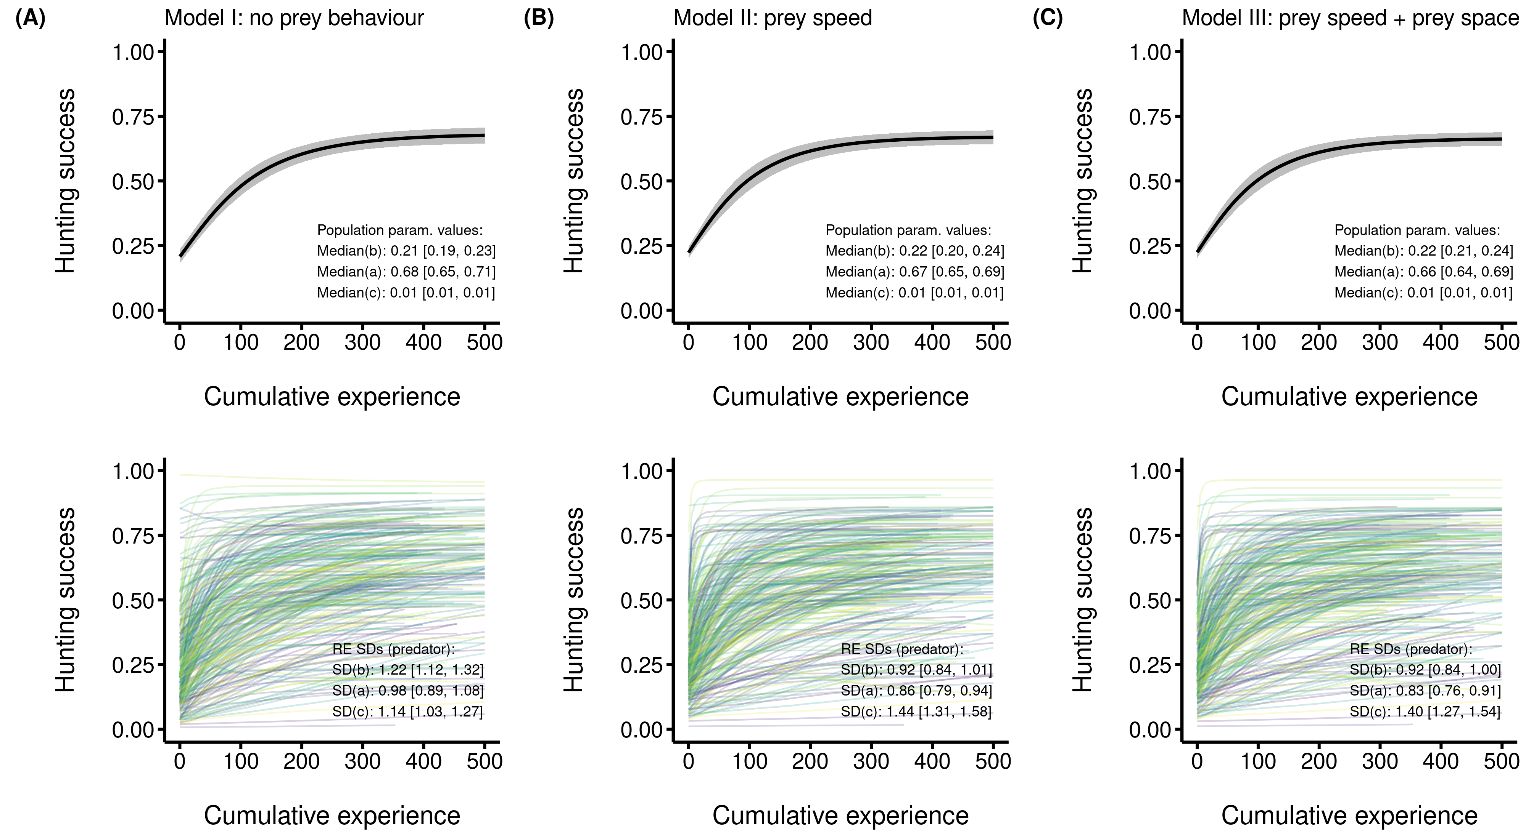

**Figure 1**. Median posterior predictions of the acquisition of predator hunting expertise. The predators’ hunting success (i.e., the probability of consuming the four prey) is on the y-axis, and the predators’ cumulative experience (i.e., the number of matches played before each observation) is on the x-axis. The results of model I (no control for prey behaviour), model II (control for prey speed), and model III (control for prey speed and space covered) are presented in panels, A, B, and C respectively. Panels on the upper row show the predicted acquisition of expertise for the average individual alongside the median posterior values of the asymptotic model parameters. Panels on the lower row show among-individual differences in the acquisition of expertise, with each curve representing an individual predator. The median posterior standard deviations of the individual predator random effect are shown. All models displayed include the game duration and the prey rank as covariates, which are held constant at their mean values.

We did not find evidence that prey behaviour had an effect on the predator population’s gain in expertise. Controlling for prey speed and space coverage did not qualitatively alter the form of the relationship between success and experience at the population level (Figure 1). Yet, model III, which included all prey features, was the best at predicting the acquisition of predator expertise (Table 2).

Table 2. WAIC comparison results for the three asymptotic mixed models estimating the relationship between hunting success (y) and predator experience (x). All models include game duration and prey rank as covariates. Models differ in the prey behavioural covariates included on asymptotic parameters.

| Model | elpd WAIC (SE)a | elpd difference (SE) |
| --- | --- | --- |
| Model III: prey speed and prey space covered | -136632.9 (202.4) | 0.0 (0.0) |
| Model II: prey speed | -136722.4 (201.9) | -89.5 (18.7) |
| Model I: no prey features | -141847.9 (183.4) | -5215.0 (109.9) |
| a 'elpd' refers to the expected log pointwise predictive density, which is the expected log probability of observing new data. Higher values indicate greater predictive accuracy. | | |

## Prey skill and antipredator behaviour

Prey groups composed of individuals with greater skill moved faster than those composed of individuals with lower skill (Figure 2A). In contrast, **there was no change in prey space coverage with increasing skill (Figure 2B)**. We found strong evidence that hunting success declined when predators pursued faster prey (Figure S2 A). However, predators were slightly more successful when hunting prey that covered space at a faster rate (Figure S2 B). Predators were also less successful when hunting prey of greater skill (i.e. lower rank values, Figure S2 C).

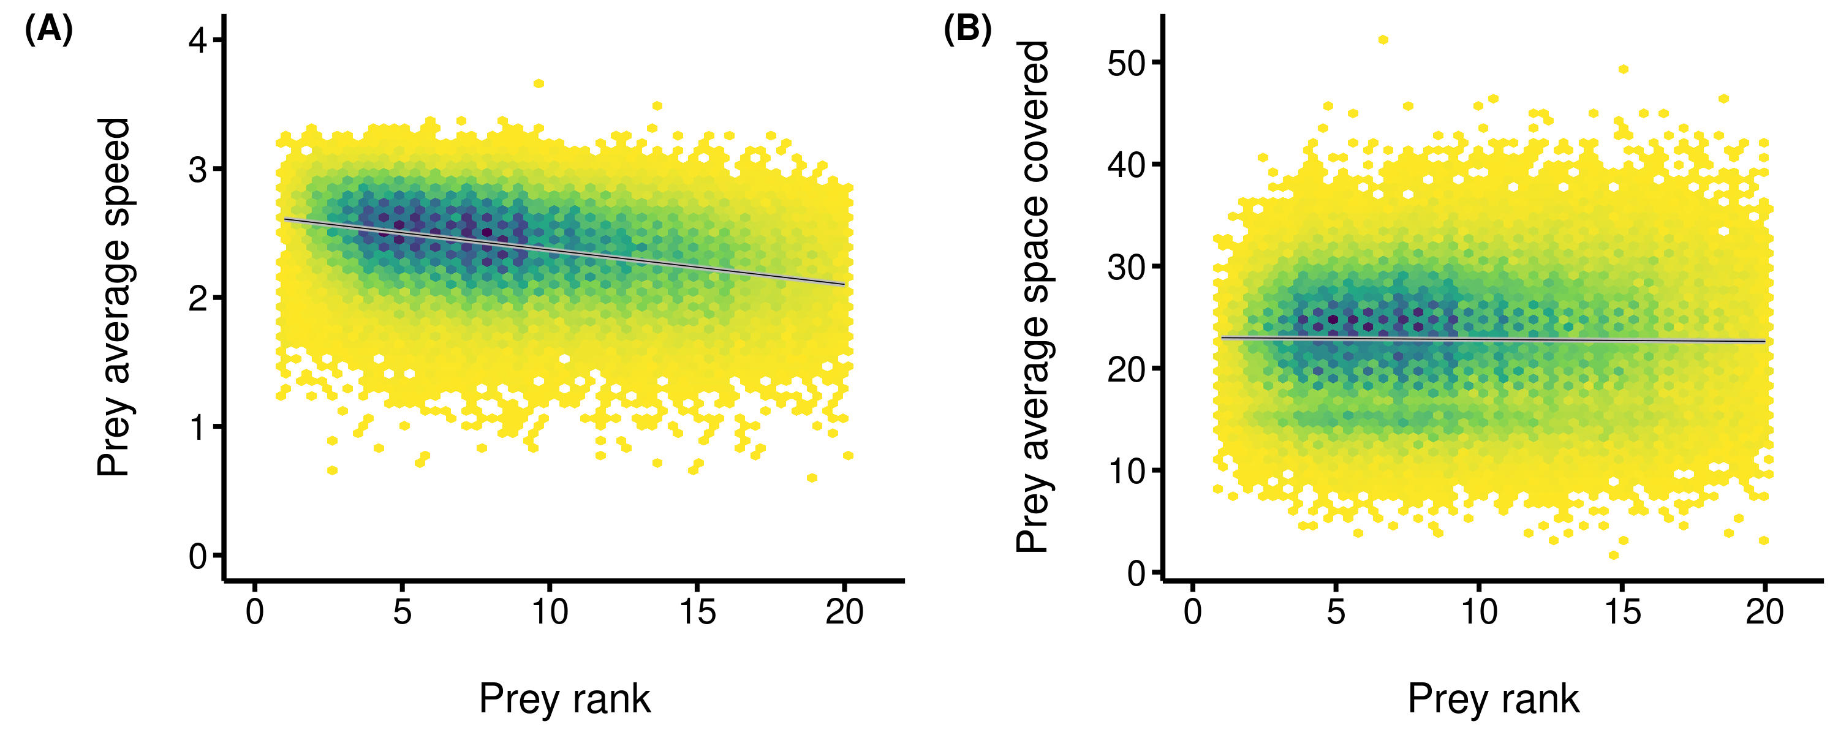

**Figure 2**. Median posterior predictions of the relationship between prey behaviour and prey skill. The average behaviour of the prey group is on the y-axis, and the average rank of the prey group is on the x-axis. The colour gradient showcases the density of observations, with lighter colours indicating lower densities, and darker colours indicating higher densities of observations. The black line represents the median posterior predictions, and the gray bands are the 89% comptability intervals. Lower rank values indicate that the prey group is more skilled, while higher values indicate that the prey are less skilled. Panel A is for the linear model of prey speed, and panel B is for the linear model of prey space coverage.

## Acquisition of expertise at the individual level

Our results show that individual predators displayed substantial differences in their acquisition of expertise (Figure 1A-C). However, we did not detect an effect of prey behaviour on individual rates of gain in expertise (Figure 3). There was also no effect of prey space coverage on the predator’s maximum hunting success (Figure 3). Yet, there was a marginal negative effect of prey speed on the maximum hunting success, suggesting that predators that encountered faster prey over time had a lower maximum hunting success (Figure 3).

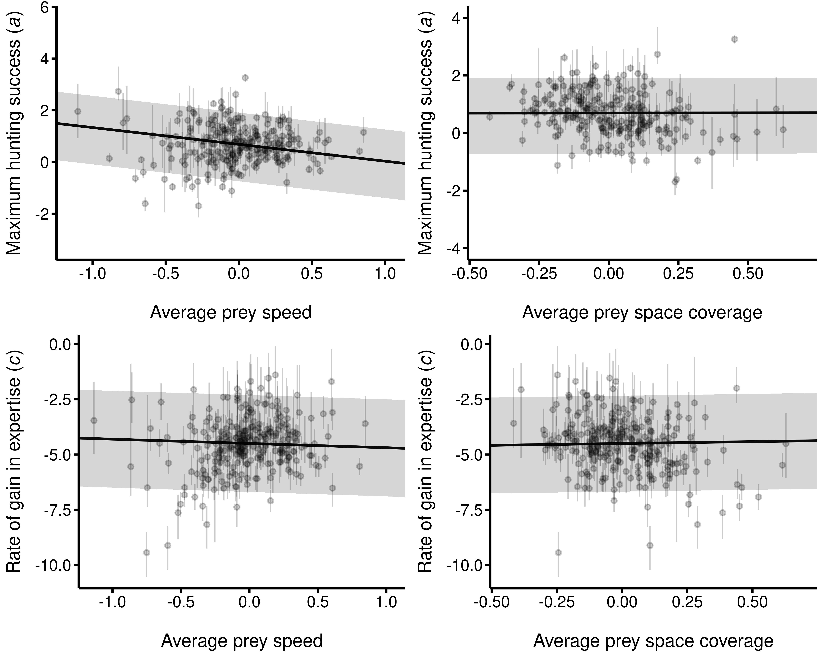

**Figure 3**. Predicted relationships between the asymptotic model parameters describing expertise acquisition and prey behaviour. Individual observations are the posterior median parameter values for each predator. The black line represents the median posterior predictions, and the gray band the 89% compatibility intervals. (Upper left) Maximum hunting success (a) as a function of the average speed of the prey group. (Upper right) Maximum hunting success (a) as a function of the average space coverage of the prey group. (Lower left) Rate of gain in expertise (c) as a function of the average speed of the prey group. (Lower right) Rate of gain in expertise (c) as a function of the average space coverage of the prey group. The predictions are from model III.

The standard deviation of the rate of gain in expertise in model I (median model I = 1.14, 89% CI: [1.03, 1.27]) was smaller than those of model II and model III (Figure 4). Differences in the rate of expertise acquisition among predators were similar in model II and model III (median model II = 1.44, 89% CI: [1.31, 1.58] vs median model III = 1.40, 89% CI: [1.27, 1.54]), with the posterior distributions of the standard deviations showing nearly complete overlap (Figure 4). Hence, including prey space coverage did not explain additional variation in the rate of expertise acquisition among predators.

We found weak evidence that the standard deviation of the maximum hunting success of model I (median model I = 0.98, 89% CI: [0.89, 1.08]) was slightly greater than those of model II and model III (Figure 4). Compared to model II, among-individual differences in maximum hunting success remained unchanged after accounting for prey space coverage (median model II = 0.86, 89% CI: [0.79, 0.94] vs median model III = 0.83, 89% CI: [0.76, 0.91]).

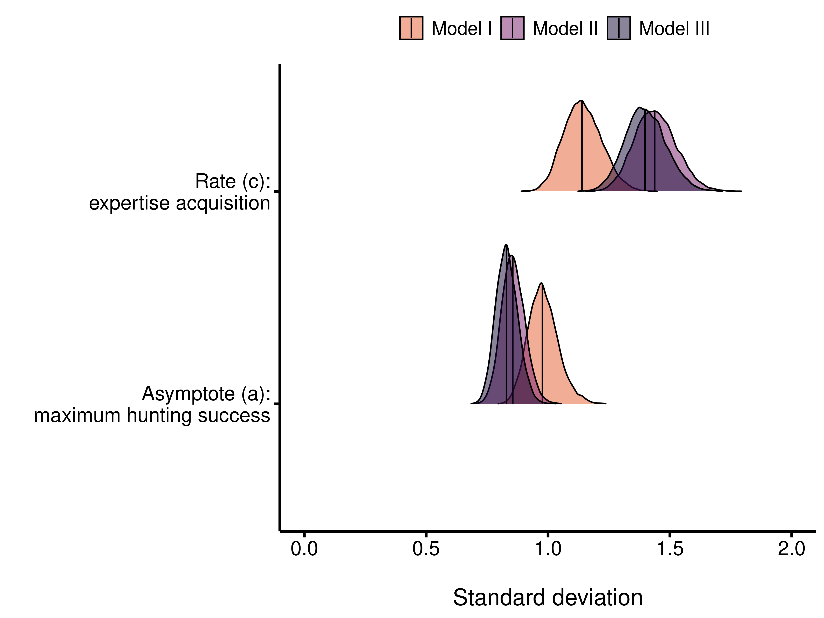

**Figure 4**. Posterior distributions of individual random effect standard deviations for asymptotic parameters. The asymptotic parameters are displayed on the y-axis, and their standard deviation values are displayed on the x-axis. The vertical lines are the medians of the posterior distributions. The light pink (lightest) distributions are for the model accounting only for the game duration and prey rank (model I), the light purple (lighter) distributions are for the model accounting for game duration and the prey rank and prey speed on asymptotic parameters (model II), and the dark purple (darker) distributions are for the model accounting for the game duration, the prey rank and all prey behaviours on asymptotic parameters (model III).

Individuals that had a low initial hunting success ended up with a lower maximum hunting success (Figure 5). In addition, individuals with the greatest maximum hunting success were those with a lower rate of gain in expertise (Figure 5). However, this relationship was decoupled when we accounted for prey behaviour in the model (cor: -002, 89% CI: [-0.16, 0.12]), indicating that prey behaviour influenced the relationship between the maximum hunting success and the rate of gain in expertise. Lastly, there was no apparent relationship between the individual rates of gain in expertise and the maximum hunting success (Figure 5).

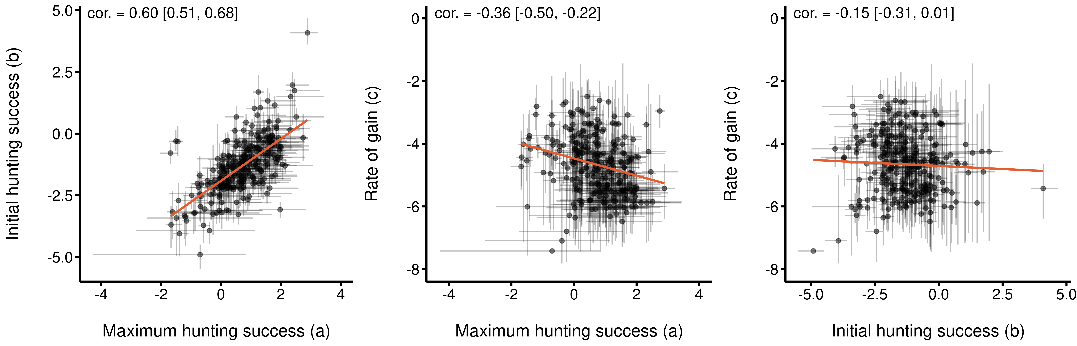

**Figure 5**. Among-individual correlations between the asymptotic model parameters. Each point represents the median posterior parameter value with the 89% credible interval for a single predator player. The left panel shows the relationship between the initial hunting success (b) and the maximum hunting success (a). The center panel shows the relationship between the rate of gain in expertise (c) and the maximum hunting success (a). The left panel shows the relationship between the rate of gain in expertise (c) and the initial hunting success (b). The correlations reported in this figure come from the model that does not account for prey behaviour (Model I).

# DISCUSSION

Using a virtual predator-prey system where we monitored interactions over repeated encounters, we tested the hypothesis that prey behaviour modulates the acquisition of predator hunting expertise. We show that, on average, predators are expected to increase their hunting success with experience when hunting prey of average skill. Overall, prey behaviour did not influence the rate of expertise acquisition. However, predators that encountered slower prey over their experience achieved greater maximum hunting success, which is most likely due to faster prey being more difficult to capture. This is supported by our analysis showing that prey of greater skill moved faster. The extent of the variation in expertise acquisition among individuals was shaped by the prey’s skill and the game pairing system, as observed by comparing the posterior distributions of individual-level parameters among models with and without the prey behaviour (Figure 4). Predators displayed important differences in expertise acquisition that were apparent only after accounting for prey skill. Accounting for prey behaviour further revealed variation in expertise acquisition that was masked by the pairing system. While we cannot establish whether prey behavior causally influenced expertise acquisition due to this game feature, our observations suggest that prey behavior may play a role in shaping individual differences in expertise acquisition by limiting the maximum hunting success achievable.

The matchmaking algorithm in *Dead by Daylight* is intended to pair players with similar skill levels within matches: failing to account for it results in predators maintaining a near constant hunting success over repeated encounters. Controlling for the prey’s skill (i.e., prey rank) in our models reveals an asymptotic relationship between hunting success and experience, wherein initial gains in success were significant (expertise increased rapidly from the first match up to 150 matches) and gradually stabilized as experience accumulated. This pattern of expertise acquisition is consistent with empirical studies in both humans and nonhuman animals (reviewed in Dukas 2019), and could be explained by improvements in foraging performance. For example, predators may have improved at locating prey, learned how to navigate the environment, or developed increased dexterity at handling prey (Dukas 2008; Reid, Seebacher, and Ward 2010). Our observations also provide clues on how expertise acquisition may change given the difficulty of the task. We observed that experienced predators could achieve greater long term success if they were not matched to highly skilled prey, or have a slower gain in expertise if the skill of the prey encountered was consistently higher (Figure S3). This is further supported by our results showing lower average hunting success against prey of greater skill (Figure S2). Whether this is due to the prey interfering with cognitive processes that limit improvements in foraging performance remains to be tested.

Our findings suggest a marginal effect of prey behaviour in shaping expertise acquisition in predators. We found that the maximum hunting success was slightly lower in predators that mostly encountered faster prey. We previously showed in *Dead by Daylight* that faster movement is effective for prey to evade predation (Fraser Franco et al. 2022), a pattern observed in studies involving other animals (Walker et al. 2005; Kelley and Magurran 2011; Martin et al. 2022). Prey of greater skill increasingly relied on faster movement, and predators were less successful against skillful prey, suggesting that the effect of prey skill on the gain in expertise by predators was in part mediated by changes in prey behaviour following previous encounters (Tetzlaff, Sperry, and DeGregorio 2019). Different mechanisms may explain why faster prey were more difficult to hunt. For example, predators have limited attention spans that influence prey choice and the formation of search images when they need to focus on hunting multiple prey simultaneously (Dukas and Kamil 2001; Troscianko, Skelhorn, and Stevens 2018). If the prey group was consistently moving faster in a coordinated fashion, then it would be difficult for predators to focus on a single prey while others rapidly progress on collecting resources (Ioannou, Guttal, and Couzin 2012). Rapid prey movements are often accompanied by unpredictability, which has been shown to hinder pursuit and increase the likelihood of predators abandoning the chase (Herbert-Read et al. 2017; Richardson et al. 2018; Jones, Jackson, and Ruxton 2011). Moreover, chasing faster prey demands specialized cognitive abilities and coordination that are energetically costly (Kelley and Magurran 2011). Hence, there may be neurological contraints that limit a predator’s ability to hunt multiple fast moving prey simultaneously. Parallel observations have been outlined in studies of prey camouflage strategies. Troscianko, Skelhorn, and Stevens (2018) showed in a computer experiment involving humans that disruptive camouflage was efficient at preventing the acquisition of expertise by interfering with search image formation. Hence, our analyses provide evidence that prey movement behaviour could mediate the acquisition of hunting expertise by limiting long term hunting success in predators. It is worth noting that our models only capture linear effects on expertise acquisition; however, the distribution of individual rates of expertise acquisition suggest potential nonlinear dynamics that warrant further investigation, such as predators improving optimally at certain prey speed levels (Figure 3).

After accounting for prey behaviour, individual predators still displayed important differences in the acquisition of expertise, indicating that they varied in their capacity to improve over time. This implies that other proximal or ecological factors may be at play. For example, longer time intervals between hunting events are hypothesized to hinder or delay the acquisition of expertise due to information loss (Endler 1991; Wright et al. 2022; Wooster et al. 2023). A predator that played 300 matches within six months might forget critical information related to prey detection or escape patterns compared to one that played 300 matches within six weeks. Alternatively, predators may also shape their own expertise via their hunting tactic. Faster hunters may push their prey to move faster or to display altruistic behaviours, which, in turn, may hinder their own expertise acquisition due to the increased difficulty of hunting such prey (Fraser Franco et al. 2022; Céré, Kelly, and Montiglio 2024). However, integrating the effects of proximal mechanisms, the predator’s tactics, and the prey’s behaviour into a unified framework to investigate expertise acquisition remains challenging, due to computational constraints and limitations in current modeling approaches.

Interestingly, we also observed relationships between expertise parameters. Individuals that had a lower initial hunting success ended up with a lower maximum hunting success, and vice-versa. Moreover, individuals with a lower rate of gain achieved greater maximum hunting success. One possible explanation is that a “slow and steady” learning strategy was beneficial in the long term. Slow learners are expected to be more sensitive to their environment in early learning phases, which allows them to gather more information and be less prone to errors in decision-making in the long term (Sih and Del Giudice 2012). Empirical studies show that slow learners tend to be more explorative and flexible when their environment changes, while fast learners tend to be more rigid in the long term (Moreira, Pulman, and Pottinger 2004; Coppens, de Boer, and Koolhaas 2010). As a result, predators that gained expertise at a slower rate may have explored different strategies before finding the optimal tactic to hunt their prey. However, an alternative explanation is that the nature of our hunting success variable (i.e., a maximum of four prey captures per game) may have produced a ceiling effect that reinforced the observed negative correlation between rates of gain and the maximum hunting success. Indeed, we can see in Figure 1 that a portion of predators with a greater baseline hunting success maintained an elevated hunting success across their experience that would necessarily result in their rate being lower. However, this appears to be the case only for a a small subset of individuals. In addition, we can see that individuals who started at a lower initial hunting success did not end up with an elevated maximum hunting success, suggesting that the ecological and cognitive mechanisms discussed above, such as encountering faster prey, are more likely to explain these patterns.

One criticism of using videogames to study behaviour is that neither the predator’s nor the prey player’s life is at stake in the game. This may partly explain the observed persistence of differences among individuals in expertise acquisition. Hence, the gain in expertise may have been driven by the players’ motivation to win rather than “true” survival. For instance, some players may experiment with the game out of boredom, which could contribute to shaping how expertise is honed in this particular system. Yet, motivation and perseverance have been outlined as core components that increase the gain in expertise in human and nonhuman hunters (Dukas 2019). Thus, we believe that failing to account for motivation represents a limitation of our study more than the use of videogames to study ecological interactions.

## Conclusions

We found partial support for the hypothesis that prey antipredator behaviour can drive the acquisition of hunting expertise using a human predator population in the game *Dead by Daylight*. The effect of prey movement behaviour on expertise acquisition was observed only on the maximum hunting success. While there were important differences among individuals in expertise acquisition, we did not find conclusive evidence that they were mediated by the prey’s movement behaviour. Future analyses should incorporate cognitive, physical and behavioural attributes of the prey to assess their influence on the acquisition of predator expertise, which may reveal important insights into the eco-evolutionary dynamics of predator-prey interactions. Our demonstration of how prey antipredator behaviour can mediate the acquisition of hunting expertise adds to a growing body of research showing how virtual systems can be used to test hypotheses on ecological interactions (Beauchamp 2020; Céré, Montiglio, and Kelly 2021; Fraser Franco et al. 2022; Lymbery, Webber, and Didham 2023; Santostefano, Fraser Franco, and Montiglio 2024). We hope that this will inspire more collaborations between scientists and the videogame industry to tackle fundamental questions in ecology.

# Data availability

The data and code used to produce our analyses are fully available on this GitHub repository: <https://github.com/quantitative-ecologist/predator-expertise>.

# REFERENCES

Abrams, Peter A. 2000. “The Evolution of Predator-Prey Interactions: Theory and Evidence.” *Annual Review of Ecology and Systematics* 31 (1): 79–105. <https://doi.org/10.1146/annurev.ecolsys.31.1.79>.

Beauchamp, Guy. 2020. “Predator Attack Patterns Influence Vigilance in a Virtual Experiment.” *Behavioral Ecology and Sociobiology* 74 (4): 49. <https://doi.org/10.1007/s00265-020-02833-0>.

Brosnan, Sarah F., and Erik Postma. 2017. “Humans as a Model for Understanding Biological Fundamentals.” *Proceedings of the Royal Society B: Biological Sciences* 284 (1869): 20172146. <https://doi.org/10.1098/rspb.2017.2146>.

Bürkner, Paul-Christian. 2017. “Brms: An R Package for Bayesian Multilevel Models Using Stan.” *Journal of Statistical Software* 80 (1): 1–28. <https://doi.org/10.18637/jss.v080.i01>.

Céré, Julien, Clint D. Kelly, and Pierre-Olivier Montiglio. 2024. “Untangling the Contribution of Active and Passive Group Augmentation Benefits to the Multilevel Selection of Altruism Using a Video Game.” *Behavioral Ecology and Sociobiology* 78 (6): 66. <https://doi.org/10.1007/s00265-024-03463-6>.

Céré, Julien, Pierre-Olivier Montiglio, and Clint D Kelly. 2021. “Indirect Effect of Familiarity on Survival: A Path Analysis on Video Game Data.” *Animal Behaviour* 181: 105–16. <https://doi.org/10.1016/j.anbehav.2021.06.010>.

Clarke, Alasdair D. F., and Amelia R. Hunt. 2025. “Learn More from Your Data with Asymptotic Regression.” *Journal of Experimental Psychology: General* 154 (5): 1250–67. https://doi.org/<https://doi.org/10.1037/xge0001710>.

Coppens, Caroline M., Sietse F. de Boer, and Jaap M. Koolhaas. 2010. “Coping Styles and Behavioural Flexibility: Towards Underlying Mechanisms.” *Philosophical Transactions of the Royal Society B: Biological Sciences* 365 (1560): 4021–28. <https://doi.org/10.1098/rstb.2010.0217>.

De Resende, Briseida Dogo, Eduardo B. Ottoni, and Dorothy M. Fragaszy. 2008. “Ontogeny of Manipulative Behavior and Nut-Cracking in Young Tufted Capuchin Monkeys (Cebus Apella): A Perception–Action Perspective.” *Developmental Science* 11 (6): 828–40. https://doi.org/<https://doi.org/10.1111/j.1467-7687.2008.00731.x>.

Dukas, Reuven. 2008. “Life History of Learning: Performance Curves of Honeybees in the Wild.” *Ethology* 114 (12): 1195–1200. https://doi.org/<https://doi.org/10.1111/j.1439-0310.2008.01565.x>.

———. 2017. “Cognitive Innovations and the Evolutionary Biology of Expertise.” *Philosophical Transactions of the Royal Society B: Biological Sciences* 372 (1735): 20160427. <https://doi.org/10.1098/rstb.2016.0427>.

———. 2019. “Animal Expertise: Mechanisms, Ecology and Evolution.” *Animal Behaviour* 147: 199–210. <https://doi.org/10.1016/j.anbehav.2018.05.010>.

Dukas, Reuven, and Alan C. Kamil. 2001. “Limited attention: the constraint underlying search image.” *Behavioral Ecology* 12 (2): 192–99. <https://doi.org/10.1093/beheco/12.2.192>.

Edwards, G. B., and Robert R. Jackson. 1994. “The Role of Experience in the Development of Predatory Behaviour in Phidippus Regius, a Jumping Spider (Araneae, Salticidae) from Florida.” *New Zealand Journal of Zoology* 21 (3): 269–77. <https://doi.org/10.1080/03014223.1994.9517994>.

Endler, J. A. 1991. “Interactions Between Predators and Prey.” In *Behavioural Ecology*, edited by J. R. Krebs and N. B. Davies, Third, 169–96. Oxford: Blackwell.

Fraser Franco, Maxime, Francesca Santostefano, Clint D Kelly, and Pierre-Olivier Montiglio. 2022. “Studying Predator Foraging Mode and Hunting Success at the Individual Level with an Online Videogame.” *Behavioral Ecology* 33 (5): 967–78. <https://doi.org/10.1093/beheco/arac063>.

Gabry, Jonah, and Rok Češnovar. 2021. “Cmdstanr: R Interface to "CmdStan".”

Hairston Jr., Nelson G., and Nelson G. Hairston Sr. 1993. “Cause-Effect Relationships in Energy Flow, Trophic Structure, and Interspecific Interactions.” *The American Naturalist* 142 (3): 379–411. <https://doi.org/10.1086/285546>.

Helton, William S. 2005. “Animal Expertise, Conscious or Not.” *Animal Cognition* 8: 67–74. https://doi.org/<https://doi.org/10.1007/s10071-004-0234-y>.

Herbert-Read, J. E., A. J. W. Ward, D. J. T. Sumpter, and R. P. Mann. 2017. “Escape Path Complexity and Its Context Dependency in Pacific Blue-Eyes (Pseudomugil Signifer).” *Journal of Experimental Biology* 220 (11): 2076–81. <https://doi.org/10.1242/jeb.154534>.

Ioannou, C. C., V. Guttal, and I. D. Couzin. 2012. “Predatory Fish Select for Coordinated Collective Motion in Virtual Prey.” *Science* 337 (6099): 1212–15. <https://doi.org/10.1126/science.1218919>.

Jones, Katherine A., Andrew L. Jackson, and Graeme D. Ruxton. 2011. “Prey Jitters; Protean Behaviour in Grouped Prey.” *Behavioral Ecology* 22 (4): 831–36. <https://doi.org/10.1093/beheco/arr062>.

Kasumovic, Michael M., Khandis Blake, and Thomas F. Denson. 2017. “Using Knowledge from Human Research to Improve Understanding of Contest Theory and Contest Dynamics.” *Proceedings of the Royal Society B: Biological Sciences* 284 (1869): 20172182. <https://doi.org/10.1098/rspb.2017.2182>.

Kelley, Jennifer L., and Anne E. Magurran. 2011. “Learned Defences and Counterdefences in Predator-Prey Interactions.” In *Fish Cognition and Behavior*, 36–58. John Wiley & Sons, Ltd. <https://doi.org/10.1002/9781444342536.ch3>.

Kikuchi, David W., and Margaret W. Simon. 2023. “Social Learning of Innovations in Dynamic Predator-Prey Systems.” *The American Naturalist* 201 (6): 895–907. <https://doi.org/10.1086/724491>.

Kondoh, Michio. 2010. “Linking Learning Adaptation to Trophic Interactions: A Brain Size-Based Approach.” *Functional Ecology* 24 (1): 35–43. https://doi.org/<https://doi.org/10.1111/j.1365-2435.2009.01631.x>.

LaBarge, Laura R., Miha Krofel, Maximilian L. Allen, Russell A. Hill, Andreanna J. Welch, and Andrew T. L. Allan. 2024. “Keystone Individuals - Linking Predator Traits to Community Ecology.” *Trends in Ecology & Evolution*. https://doi.org/<https://doi.org/10.1016/j.tree.2024.07.001>.

Lönnstedt, Oona M., Mark I. McCormick, Mark G. Meekan, Maud C. O. Ferrari, and Douglas P. Chivers. 2012. “Learn and Live: Predator Experience and Feeding History Determines Prey Behaviour and Survival.” *Proceedings of the Royal Society B: Biological Sciences* 279 (1736): 2091–98. <https://doi.org/10.1098/rspb.2011.2516>.

Lymbery, Samuel J., Bruce L. Webber, and Raphael K. Didham. 2023. “Complex Battlefields Favor Strong Soldiers over Large Armies in Social Animal Warfare.” *Proceedings of the National Academy of Sciences* 120 (37): e2217973120. <https://doi.org/10.1073/pnas.2217973120>.

MacDonald, Katharine. 2007. “Cross-Cultural Comparison of Learning in Human Hunting.” *Human Nature* 18 (4): 386–402. <https://doi.org/10.1007/s12110-007-9019-8>.

Martin, Benjamin T., Michael A. Gil, Ashkaan K. Fahimipour, and Andrew M. Hein. 2022. “Informational Constraints on Predator-Prey Interactions.” *Oikos* 2022 (10): e08143. <https://doi.org/10.1111/oik.08143>.

Montiglio, Pierre-Olivier, Maxime Fraser Franco, and Francesca Santostefano. 2025. “Multiplayer Videogames to Analyze Behavior During Ecological Interactions.” *Trends in Ecology & Evolution* 40 (5): 489–501. https://doi.org/<https://doi.org/10.1016/j.tree.2025.02.003>.

Moreira, P. S. A., K. G. T. Pulman, and T. G. Pottinger. 2004. “Extinction of a Conditioned Response in Rainbow Trout Selected for High or Low Responsiveness to Stress.” *Hormones and Behavior* 46 (4): 450–57. <https://doi.org/10.1016/j.yhbeh.2004.05.003>.

Morse, Douglass H. 2000. “The Effect of Experience on the Hunting Success of Newly Emerged Spiderlings.” *Animal Behaviour* 60 (6): 827–35. <https://doi.org/10.1006/anbe.2000.1546>.

Pettorelli, Nathalie, Anne Hilborn, Clare Duncan, and Sarah M. Durant. 2015. “Chapter Two - Individual Variability: The Missing Component to Our Understanding of Predator-Prey Interactions.” In *Trait-Based Ecology - from Structure to Function*, edited by Samraat Pawar, Guy Woodward, and Anthony I. Dell, 52:19–44. Advances in Ecological Research. Academic Press. https://doi.org/<https://doi.org/10.1016/bs.aecr.2015.01.001>.

Piironen, Juho, and Aki Vehtari. 2017. “Comparison of Bayesian Predictive Methods for Model Selection.” *Statistics and Computing* 27 (3): 711–35. <https://doi.org/10.1007/s11222-016-9649-y>.

Quevedo, Mario, Richard Svanbäck, and Peter Eklöv. 2009. “Intrapopulation Niche Partitioning in a Generalist Predator Limits Food Web Connectivity.” *Ecology* 90 (8): 2263–74. https://doi.org/<https://doi.org/10.1890/07-1580.1>.

Reid, Amelia, Frank Seebacher, and Ashley Ward. 2010. “Learning to Hunt: The Role of Experience in Predator Success.” *Behaviour* 147 (2): 223–33. <https://doi.org/10.1163/000579509X12512871386137>.

Richardson, Graham, Patrick Dickinson, Oliver H. P. Burman, and Thomas W. Pike. 2018. “Unpredictable Movement as an Anti-Predator Strategy.” *Proceedings of the Royal Society B: Biological Sciences* 285 (1885): 20181112. <https://doi.org/10.1098/rspb.2018.1112>.

Ripple, William J., James A. Estes, Robert L. Beschta, Christopher C. Wilmers, Euan G. Ritchie, Mark Hebblewhite, Joel Berger, et al. 2014. “Status and Ecological Effects of the World’s Largest Carnivores.” *Science* 343 (6167): 1241484. <https://doi.org/10.1126/science.1241484>.

Rutz, Christian. 2012. “Predator Fitness Increases with Selectivity for Odd Prey.” *Current Biology* 22 (9): 820–24. https://doi.org/<https://doi.org/10.1016/j.cub.2012.03.028>.

Santostefano, Francesca, Maxime Fraser Franco, and Pierre-Olivier Montiglio. 2024. “Social interactions generate complex selection patterns in virtual worlds.” *Journal of Evolutionary Biology* 37 (7): 807–17. <https://doi.org/10.1093/jeb/voae055>.

Schmitz, Oswald. 2017. “Predator and Prey Functional Traits: Understanding the Adaptive Machinery Driving Predator-Prey Interactions.” *F1000Research* 6 (1767). <https://doi.org/10.12688/f1000research.11813.1>.

Sih, Andrew, and Marco Del Giudice. 2012. “Linking Behavioural Syndromes and Cognition: A Behavioural Ecology Perspective.” *Philosophical Transactions of the Royal Society B: Biological Sciences* 367 (1603): 2762–72. <https://doi.org/10.1098/rstb.2012.0216>.

Skelhorn, John, and Candy Rowe. 2016. “Cognition and the Evolution of Camouflage.” *Proceedings of the Royal Society B: Biological Sciences* 283 (1825): 20152890. <https://doi.org/10.1098/rspb.2015.2890>.

Stan Development Team. 2023. *Stan Modeling Language Users Guide and Reference Manual*. 2.31 ed.

Stevens, Martin, Kate L. A. Marshall, Jolyon Troscianko, Sive Finlay, Dan Burnand, and Sarah L. Chadwick. 2012. “Revealed by conspicuousness: distractive markings reduce camouflage.” *Behavioral Ecology* 24 (1): 213–22. <https://doi.org/10.1093/beheco/ars156>.

Tetzlaff, Sasha J., Jinelle H. Sperry, and Brett A. DeGregorio. 2019. “Effects of Antipredator Training, Environmental Enrichment, and Soft Release on Wildlife Translocations: A Review and Meta-Analysis.” *Biological Conservation* 236: 324–31. https://doi.org/<https://doi.org/10.1016/j.biocon.2019.05.054>.

Troscianko, Jolyon, Alice E. Lown, Anna E. Hughes, and Martin Stevens. 2013. “Defeating Crypsis: Detection and Learning of Camouflage Strategies.” *PLOS ONE* 8 (9): 1–8. <https://doi.org/10.1371/journal.pone.0073733>.

Troscianko, Jolyon, John Skelhorn, and Martin Stevens. 2018. “Camouflage Strategies Interfere Differently with Observer Search Images.” *Proceedings of the Royal Society B: Biological Sciences* 285 (1886): 20181386. <https://doi.org/10.1098/rspb.2018.1386>.

Turner, Andrew M., Sarah E. Turner, and Heidi M. Lappi. 2006. “Learning, Memory and Predator Avoidance by Freshwater Snails: Effects of Experience on Predator Recognition and Defensive Strategy.” *Animal Behaviour* 72 (6): 1443–50. <https://doi.org/10.1016/j.anbehav.2006.05.010>.

Vehtari, Aki, Andrew Gelman, and Jonah Gabry. 2017. “Practical Bayesian Model Evaluation Using Leave-One-Out Cross-Validation and WAIC.” *Statistics and Computing* 27 (5): 1413–32. <https://doi.org/10.1007/s11222-016-9696-4>.

Vehtari, Aki, Andrew Gelman, Daniel Simpson, Bob Carpenter, and Paul-Christian Bürkner. 2021. “Rank-Normalization, Folding, and Localization: An Improved $\Widehat{}R{}$ for Assessing Convergence of MCMC (with Discussion).” *Bayesian Analysis* 16 (2): 667–718. <https://doi.org/10.1214/20-BA1221>.

Walker, J. A., C. K. Ghalambor, O. L. Griset, D. McKENNEY, and D. N. Reznick. 2005. “Do Faster Starts Increase the Probability of Evading Predators?” *Functional Ecology* 19 (5): 808–15. <https://doi.org/10.1111/j.1365-2435.2005.01033.x>.

Watanabe, Sumio. 2010. “Asymptotic Equivalence of Bayes Cross Validation and Widely Applicable Information Criterion in Singular Learning Theory.” *Journal of Machine Learning Research* 11 (116): 3571–94. <http://jmlr.org/papers/v11/watanabe10a.html>.

Wilson-Rankin, Erin E. 2015. “Level of Experience Modulates Individual Foraging Strategies of an Invasive Predatory Wasp.” *Behavioral Ecology and Sociobiology* 69 (3): 491–99. <https://doi.org/10.1007/s00265-014-1861-1>.

Wirsing, Aaron J., Michael R. Heithaus, Joel S. Brown, Burt P. Kotler, and Oswald J. Schmitz. 2021. “The Context Dependence of Non-Consumptive Predator Effects.” *Ecology Letters* 24 (1): 113–29. https://doi.org/<https://doi.org/10.1111/ele.13614>.

Woo, Kerry J., Kyle Hamish Elliott, Melissa Davidson, Anthony J. Gaston, and Gail K. Davoren. 2008. “Individual Specialization in Diet by a Generalist Marine Predator Reflects Specialization in Foraging Behaviour.” *Journal of Animal Ecology* 77 (6): 1082–91. <https://doi.org/10.1111/j.1365-2656.2008.01429.x>.

Wooster, Eamonn I. F., Kaitlyn M. Gaynor, Alexandra J. R. Carthey, Arian D. Wallach, Lauren A. Stanton, Daniel Ramp, and Erick J. Lundgren. 2023. “Animal Cognition and Culture Mediate Predatorprey Interactions.” *Trends in Ecology & Evolution*. <https://doi.org/10.1016/j.tree.2023.09.012>.

Wright, Jonathan, Thomas R. Haaland, Niels J. Dingemanse, and David F. Westneat. 2022. “A Reaction Norm Framework for the Evolution of Learning: How Cumulative Experience Shapes Phenotypic Plasticity.” *Biological Reviews* 97 (5): 1999–2021. <https://doi.org/10.1111/brv.12879>.